

Placement Empowerment Program

Cloud Computing and DevOps Centre

Host a Static Website Locally: Set Up a Local Server Apache and Host a Simple HTML page with your name

Name: Keshika.D Department:ADS



# Introduction

In this proof of concept (POC), Overview: Hosting a Static

Website on Azure Using Apache

This task involves deploying a static website on an Azure

Virtual Machine (VM) using Apache, a widely used web server. A static website consists of fixed HTML, CSS, and JavaScript files, which do not require backend processing or databases. The process includes setting up a cloud-based VM, installing and configuring Apache, and hosting an HTML webpage accessible via a web browser. Once deployed, the website can be accessed using the public IP address of the Azure VM. This setup demonstrates fundamental cloud computing, web hosting, networking, and security concepts, providing hands-on experience with server deployment, firewall configuration, and basic web hosting in a cloud environment. It is a foundational step for learning web development, DevOps, and cloud infrastructure.

Step 1: Set Up An Azure Vm

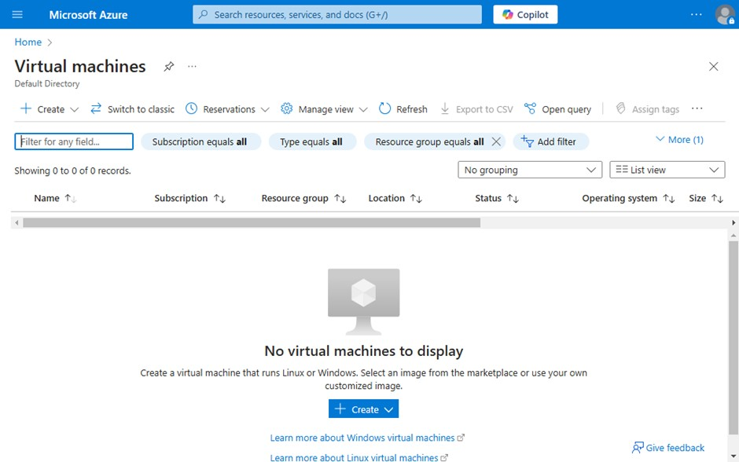

Search for virtual machine in the azure portal

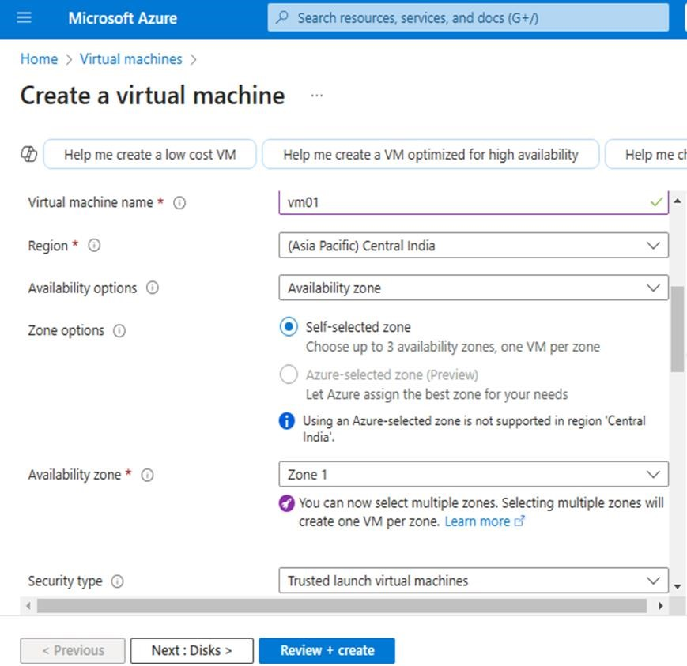

Create a VM with the following configuration and give review +create at the end

Step 2:

Connect to the vm via powershell using SSH or connection via

powershell using this command : ssh username@your-vm-ip

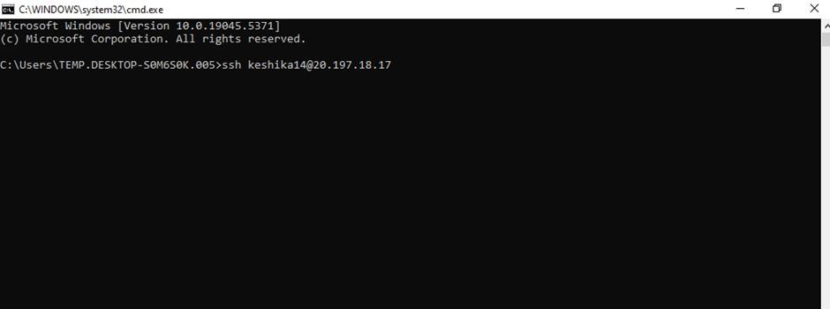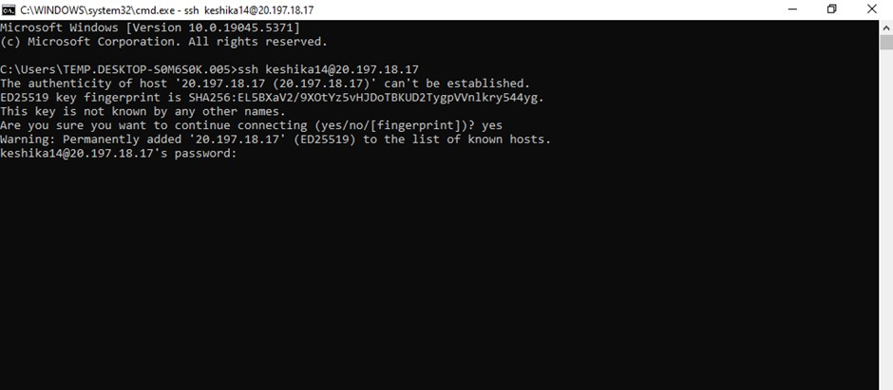

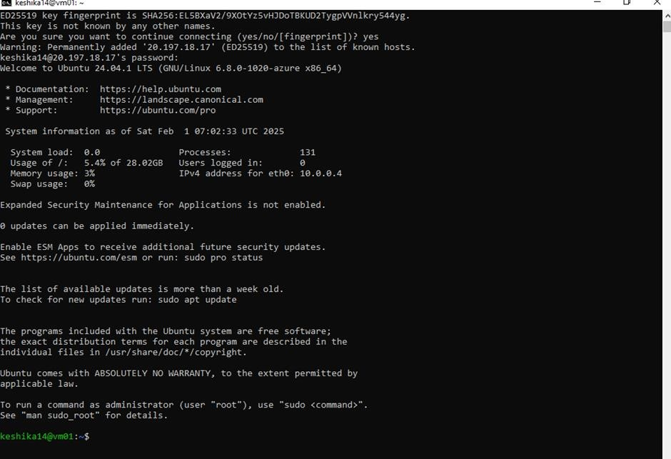

Install apache webserver after Step 3 : logging into your vm 1)Update package :

in the powershell after logging give the update package command

:**sudo apt update && sudo apt upgrade -y**

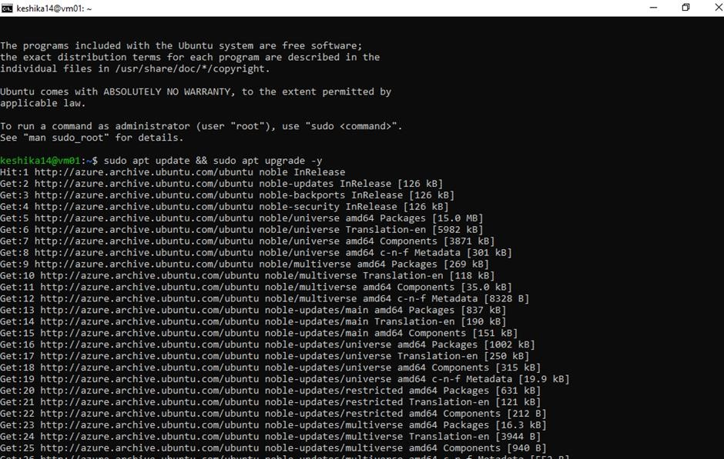

2)Install apache:

**sudo apt install apache2 -y** 3)Sart apache:

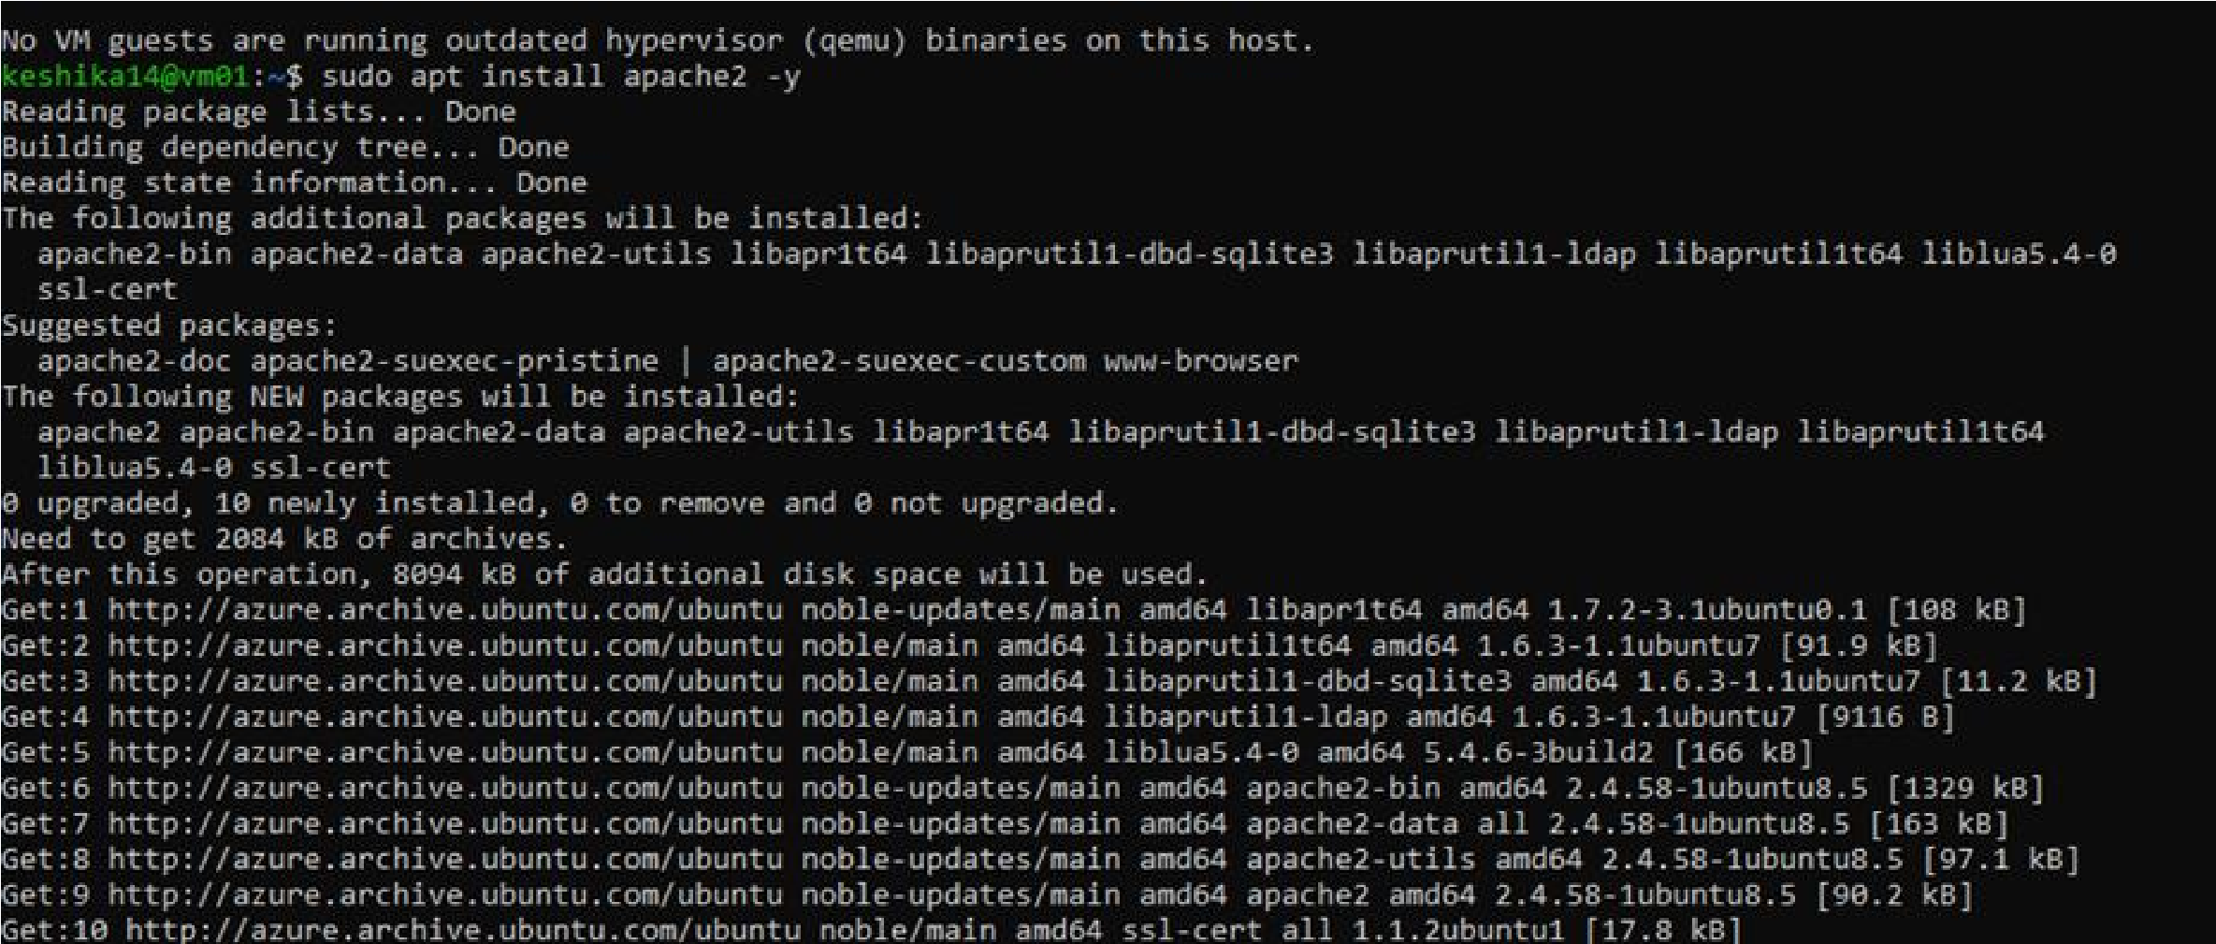**sudo systemctl start apache 2**

4)Enable apache to start on Boot: **sudo systemctl enable apache2**

command is given after giving the start apache command .refer the above image for reference

5)Check apache status:

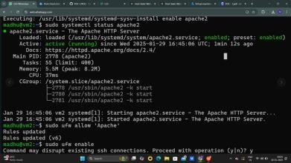

**sudo systemctl status apache**

Step 4: configure

firewall to allow HTTP Traffic

1)Allow apache through Firewall : **sudo ufw allow ‘ apache’**

2) enable firewall: **sudo ufw enable**

3)check firewall:**sudo ufw status**

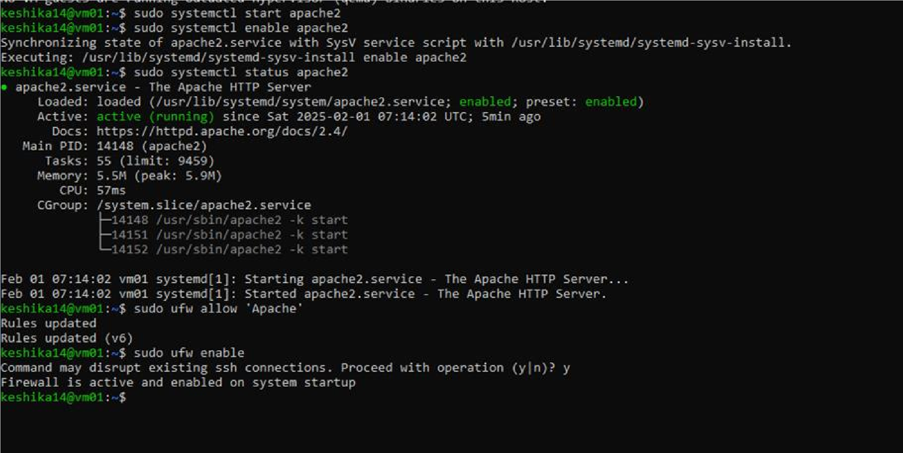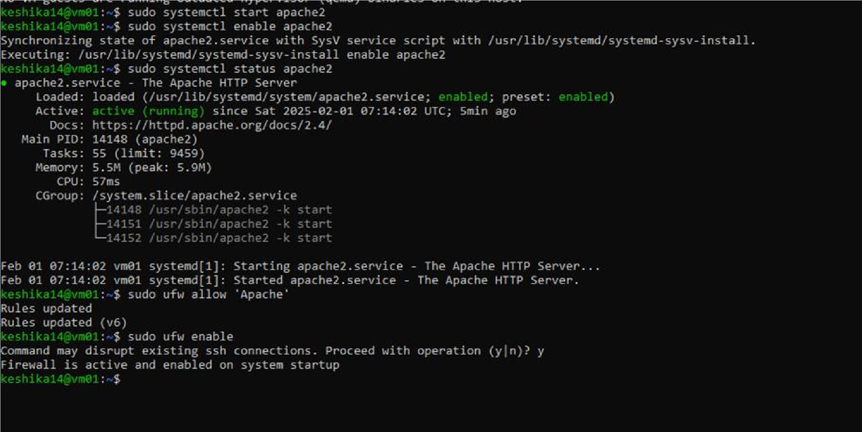

Step 5: Deploy a simple html page

1)Navigate to web root dictionary:

**Cd/var/www/html**

2)create new Html page: **sudo nano index.html** This command directly navigates to the html file so that you can paste or type in your html code there for your static website

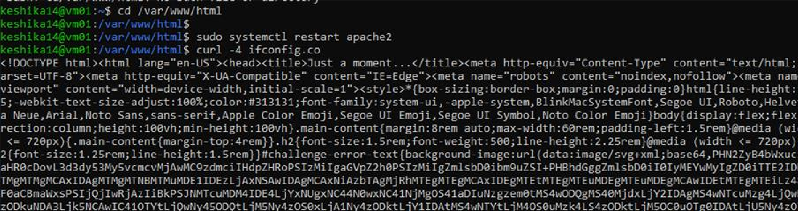

once you have finished typing in our content give **Ctrl+X then Y press enter** example content:

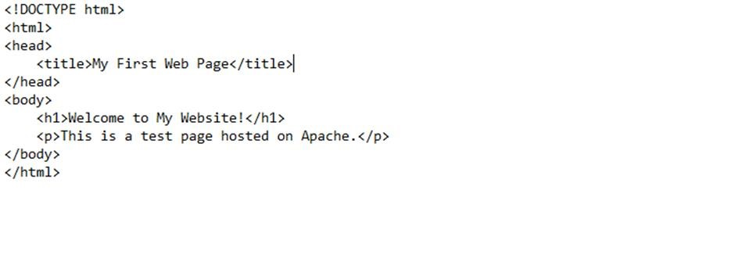

Step 6:

1) restart the apache to apply changes: **sudo systemctl restart apache2**

2)Get

your ip address: Get it from the over view page of your azure vm

you can access your website by [http://Your-vm-ip](http://your-vm-ip/)

